To add new funding to your account please follow the below steps:

Click on “user”

Click “New Fund”

Complete the below request and click “assign fund”:

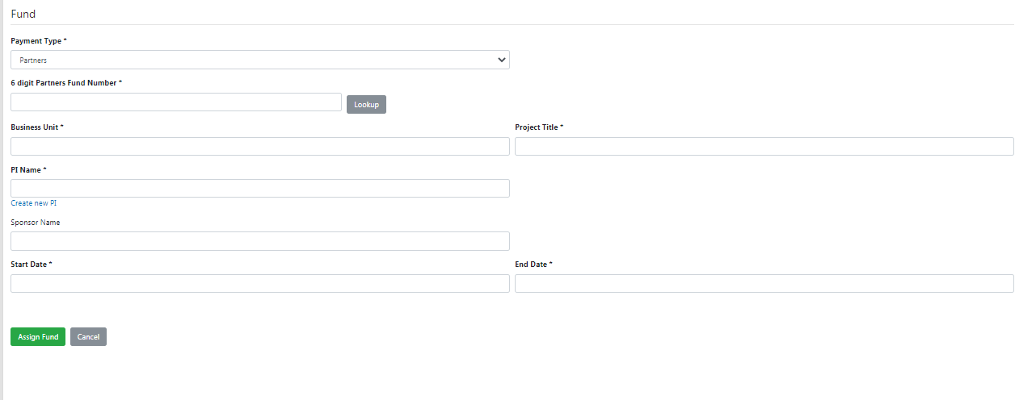

To remove the fund from your account or update your services request fund follow the below steps:

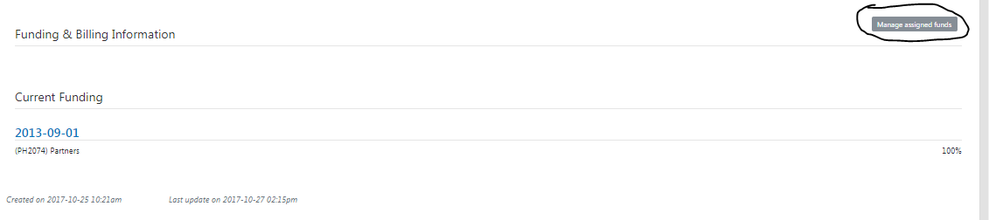

Click on “the downward arrow” and click “Edit”

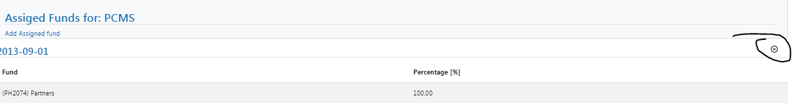

You can remove a fund or select a new fund for this services request:
